Data Sheet: Activity 2 – Conservation of Energy

All Content is Copyright Protected and May NOT Be Posted or Shared Outside Of The Classroom

Name | Course | Date

Activity Data Code

Table I – Ball Mass

Complete the table below using data found under the Activity-Form tab.

Ball 1 Mass (kg) | Ball 2 Mass (kg)
0.200 | 0.250

Table II – Launch Without Ramp

Complete the table below using data from Table I, data from your Energy Plots (see the Energy Plots tab), and information found under the Background tab.

Note: Be very careful with units to get correct answers! 1.00 cm = 0.0100 m, 100 mJ = 0.100 J.

Spring | Trial | Compression  Distance  (m) | Spring PE  (J) | K  (J/m²) | Max KE  (J) | Max Vel  (m/s)
1 | 1 | 0.09 | 0.47385 | 117 | 0.47385 | 2.177
1 | 2 | 0.07 | 0.28665 | 117 | 0.28665 | 1.693
2 | 1 | 0.09 | 0.33615 | 83 | 0.33615 | 1.64
2 | 2 | 0.07 | 0.20335 | 83 | 0.20335 | 1.275

Smple Calculation: Show your spring constant calculation for spring 1 (Trial 1).

0.09
PEs=1/2kd²

K= 2Pes/d²

=(2 x0.47385)/ 0.09²

=117 J/m²

Sample Calculation: Show your maximum velocity calculation for spring 2 (Trial 2).
K= 2Pes/d²

=(0.20335 x2)/ 0.07²

=83 J/m²

Observations and Questions

[1] Based on your Combined Energy Plot from one of your Table II data runs, is mechanical energy conserved? Use details from your plot to support your answer.

As the sum of the two energies always remains constant, which can be seen by the respected levels of two lines at all the time instances, hence the total mechanical energy is conserved.

Table III – Launch using Ramp - Never Airborne

Complete the table below using data from Table I, data from your Energy Plots (see the Energy Plots tab), and information found under the Background tab.

Note: Be very careful with units to get correct answers! 1.00 cm = 0.0100 m, 100 mJ = 0.100 J

Spring | Ball | Compression  Distance  (m) | Spring PE  (J) | Max Ramp PE  (J) | Max Ramp  Height  (m)
2 | 1 | 0.066 | 0.18077 | 0.17797 | 0.092
2 | 2 | 0.073 | 0.22115 | 0.22073 | 0.09

Sample Calculation: Show your maximum ramp height calculation for spring 2 (ball 1).

h = PE/mg

= 0.18077/(0.2 x9.8)
=0.092m

Observations and Questions

[1] Explain why the spring potential energy and maximum ramp potential energy are the same for a particular data run. If not, provide a possible explanation.

spring potential energy and maximum ramp potential energy are not the same since mechanical energy is not conserved.

[2] Based on your Combined Energy Plot, is mechanical energy conserved? Use details from this plot to support your answer. Give specific locations on the plot (times, etc.) to back up your arguments.
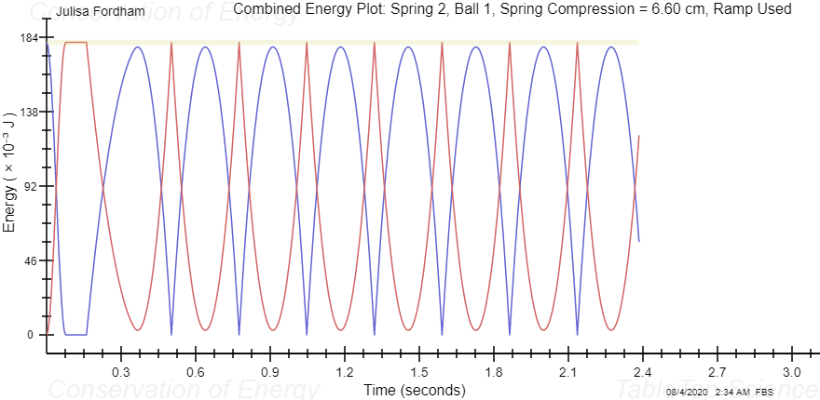

mechanical energy is conserved. The mechanical energy of the ball did not change during this drop/bounce process, at 0.075 seconds the moment the ball is dropped it has a potential energy and a zero kinetic energy.

Table IV – Airborne Launch using Ramp - Single Bounce

Complete the table below using data from Table I, data from your Energy Plots (see the Energy Plots tab), and information found under the Background tab.

Note: Be very careful with units to get correct answers! 1.00 cm = 0.0100 m, 100 mJ = 0.100 J

Spring | Ball | Compression  Distance  (m) | Spring PE  (J) | Max Airborne PE  (J) | Max Height  (m) | KE at Max Height  (J) | Max Height  Velocity  (m/s)
1 | 1 | 0.066 | 0.25483 | 0.20464 | 0.13 | 0.25483 | 1.13
1 | 2 | 0.074 | 0.32035 | 0.25645 | 0.16 | 0.32035 | 1.79

Sample Calculation: Show your maximum height calculation for ball 1.

H=PE/mg
=0.25483/ 0.2 x9.8
=0.13m

Sample Calculation: For ball 1, show your calculations for kinetic energy and velocity at maximum height. Hint: use Max Airborne PE and conservation of energy to determine KE at Max Height.

V= (2KE/m)^1/2

=(2x0.2548/0.2)^1/2
=1.129 m/s

Observations and Questions

[1] The spring potential energy and maximum airborne potential energy are not equal in table IV. Provide an explanation for the difference.
The spring is not compressed at its maximum hence the spring potential energy and maximum airborne potential energy are not equal

[2] Based on your Combined Energy Plots for ball 1 and ball 2, is mechanical energy conserved for both balls? Use details from these plots to support your answers. Give specific locations on the plot (times, etc.) to back up your arguments. Yes mechanical energy is conserved for ball one and two.

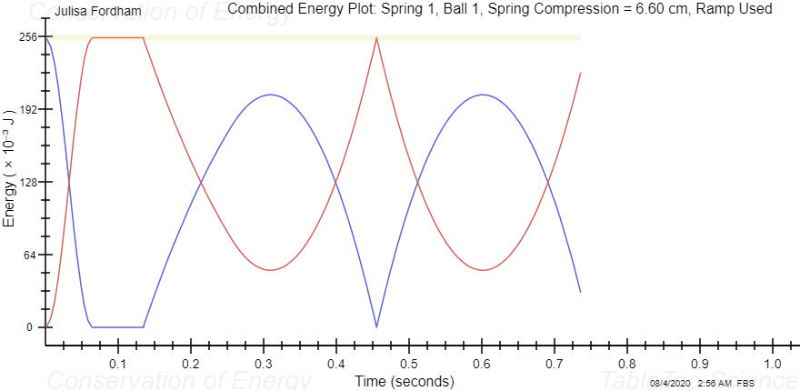
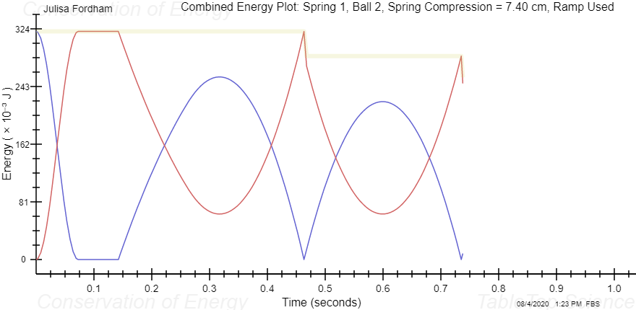

Table V – Airborne Launch with Multiple Bounces

Complete the table below using data from Table I, data from your Energy Plots (see the Energy Plots tab), and information found under the Background tab.

Tip: Your Potential Energy Plot is most useful for completing this table.

Note: Be very careful with units to get correct answers! 1.00 cm = 0.0100 m, 100 mJ = 0.100 J

Spring | Ball | Compression  Distance  (m) | Max Airborne PE  (J) | Max PE after Bounce  (J) | Coefficient  of  Restitution
2 | 1 | 0.066 | 0.17797 | 0.17797 | 1
2 | 2 | 0.074 | 0.22725 | 0.22293 | 0.99

Sample Calculation: Show your coefficient of restitution calculation for ball 1.

COR=√ (PEMaxAirborneAfter/PEMaxAirborneBefore)
=√(0.17797/0.17797)
1

Sample Calculation: Show your coefficient of restitution calculation for ball 2.

=√(0.22293/0.22725)
=0.99

Observations and Questions

[1] The maximum potential energy before and after bouncing might not be equal for both balls in table V. Provide an explanation for any differences.

The balls are of different masses and the spring is compressed at different distances hence the bell with a greater mass has a difference in maximum potential energy before and after bouncing

[2] Based on your Combined Energy Plots for ball 1 and ball 2, is mechanical energy conserved for both balls? no Use details from these plots to support your answers. Give specific locations on the plot (times, etc.) to back up your arguments. For graph 2 at 0.53 the kinetic energy and potential energy differ

